Previous Winners

1893 | W. Bryden | 1935 | L. Claxton
1894 | R. Stewart | 1937 | R. J. Allen
1895 | R. Stewart | 1939 | J. MacFarlane
1896 | R. Jordan | 1947 | J. Marshall
1897 | J. Ferrie | 1950 | D. E. Oldbury
1898 | H. Freedman | 1951 | J. Marshall
1899 | H. Freedman | 1953 | J. Marshall
1900 | R. Stewart | 1955 | J. Scott
1901 | R. Stewart | 1961 | J. Marshall
1902 | R. Stewart | 1963 | J. McGill
1903 | J. Ferrie | 1965 | J. McGill
1904 | J. Ferrie | 1967 | J. McGill
1905 | G. Buchanan | 1969 | E. Gibson
1906 | G. Buchanan | 1971 | J. McGill
1907 | G. Buchanan | 1973 | W. Edwards
1908 | J. Ferrie | 1975 | W. Edwards
1909 | G. M. Bonar | 1977 | J. McGill
1911 | J. Ferrie | 1979 | J. McGill
1912 | A. Jordan | 1981 | P. McCarthy
1913 | J. Ferrie | 1983 | J. Grant
1914 | A. B. Scott | 1985 | P. McCarthy
1915 | M. Boyle | 1987 | T. Watson
1916 | G. O’Conner | 1989 | T. Watson
1917 | L. Collingwood | 1991 | T. Watson
1918 | A. B. Scott | 1993 | W. Edwards
1919 | G. O’Conner | 1995 | J. Grant
1920 | A. B. Scott | 1997 | H. Devlin
1922 | G. O’Conner | 1999 | P. McCarthy
1923 | A. B. Scott | 2001 | T. Watson
1924 | G. O’Conner | 2003 | T. Watson
1925 | J. Campbell | 2005 | T. Watson
1926 | J. Campbell | 2007 | T. Watson
1927 | J. Campbell | 2009 | B. Docherty
1929 | A. Inglis | 2011 | T. Watson
1930 | M. Boyle | 2013 | T. Watson
1931 | R. Scobie | 2015 | T. Watson
1933 | A. Inglis | 2017 | ???????????
1934 | H. French

Scottish Draughts Association

Welcome to the

Scottish Open
Draughts
Championships
July 10th -14th
2017
Spectrum Centre, Inverness
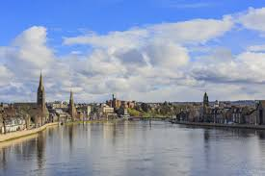
Welcome to Inverness
On behalf of the Scottish Draughts Association, I would like to extend a warm welcome to all players and friends to the 2017 Scottish Open Draughts Championships here in Inverness.
This is the third time the Scottish Draughts Association has held a tournament in the Spectrum Centre.
We acknowledge the help and co-operation we have received from the Centre management and staff ensuring the smooth running of the competitions.
I hope you all enjoy your stay in this lovely and vibrant city.
Lamont Inkster
(SDA President)
18 George Street
Kirkwall
Orkney
KW15 1PW

The Scottish Draughts Association has since 1892, worked tirelessly to promote the game of Draughts, not only in Scotland but throughout the world.

Organising and running a prestigious national open championship takes many hours and substantial amounts of money and this can only be achieved with the continued help and support from members, players and the outside community.

The Scottish Draughts Association has a close band of loyal supporters whose generosity makes the committee’s task of fundraising easier and we wish to acknowledge them here.

Thank you to all the following for their donations and support throughout the year:

The Aberdeen Draughts Club, Spectrum Centre Management and Staff, John McGill, Donald Oliphant, Lamont Inkster, Colin Young, Graham Young, The Competitors.

If we have omitted anyone then we apologise in advance.
Donald Oliphant
(SDA Secretary/Treasurer)
16 Columbus Place
Great Sankey
Warrington
WA5 8DY

Rules
Swiss System
The purpose of the Swiss system is to determine that every player shall ultimately be placed logically and easily in ranking order of merit. After the first round the pairings will be determined by the number of aggregate points scored by each player. The Chess Arbiter programme used by the referee will determine each player’s opponent in all rounds.

- Time Limit – 30 moves per hour, then 15 per half hour.
- Points Awarded – 2 per win, 1 for a draw, 0 for a loss.
- Players can only meet each other once.
- No adjudication of games.
- 156 openings will be included in the ballot. The player drawing the Black side will draw the opening. Both players to record the moves made.

- If there is an uneven number of players, the last drawn will get a bye – 4 points. This will be considered to be 2 wins; only 1 bye can be given per player.

- Tie breaking will be done by honour points. If honour points are equal, results when players met, then if still equal, least losses counts next. All rounds to be counted by honour points.

- Any player arriving late will have the clock started against them unless prior agreement has been made between players and the referee.

- The committee will have the power to make whatever arrangements are considered necessary to facilitate the running of the tournament and any decision they reach will be final.

- All mobile phones to be switched off when rounds are being played. If a player’s phone rings whilst playing they will forfeit the game.

Contacts
And Useful Information
Lamont Inkster: 07759491971

Donald Oliphant: 07917132789
Doliphant16@googlemail.com

Graham Young 07946239284

Spectrum Centre 01463 221842
1B, Margaret Street
Inverness
IV1 1LS

VisitScotland iCentre 01463 252401
Castle Wynd http://www.inverness-scotland.com/
Inverness
IV2 3BJ
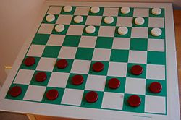

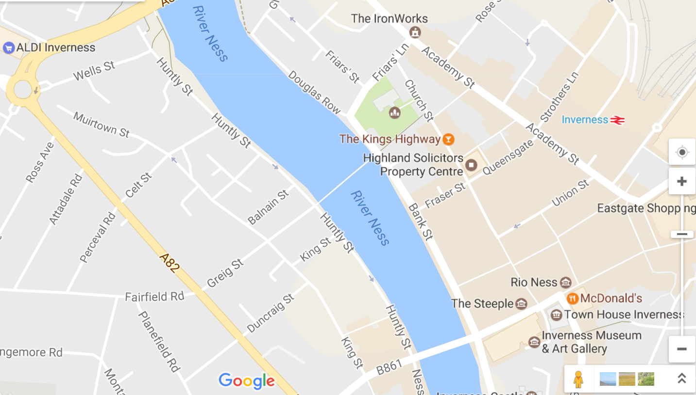
The Spectrum Centre, 1B Margaret Street, Inverness, IV1 1LS is highlighted here in orange whilst the purple arrow highlights Kenneth Street which is full of Bed and Breakfast establishments. The area surrounding Kenneth Street has plenty of hotels and guest houses to suit all budgets and Kenneth Street is only a 15 minute walk into the city centre.
The Spectrum Centre is located beside the bus station and is a short walk from the train station.
Inverness is located about 10 miles west of Dalcross airport which is served by buses and taxi which will take you straight into Inverness.
Inverness is a busy lively city with a great atmosphere and most nights live music can be found in the city centre bars, and there are many restaurants to suit every taste.

Programme
Monday, 10th July 09.30a.m. Registration and Opening Ceremony
10.00a.m. Draw for First Session
2.30p.m. Round Two
Tuesday, 11th July 10.00a.m. Round Three
2.30p.m. Round Four
Wednesday, 12th July 10.00a.m. Round Five
2.30p.m. Round Six
19.00p.m. Scottish Draughts Association AGM
Thursday, 13th July 10.00a.m. Round Seven
2.30p.m. Round Eight
Friday, 14th July 10.00a.m. Round Nine
2.30p.m. Round Ten
17.00p.m. Prize Giving Ceremony

